Early Childcare COVID-19 Surveillance: At Home Family Pooled Testing Pilot in a California Preschool
Protecting young children during the pandemic through innovations in disease screening

Randy True – CEO, FloodLAMP Biotechnologies, PBC
Theresa Ling – Program Experience and Design, FloodLAMP Biotechnologies, PBC

contact@floodlamp.bio

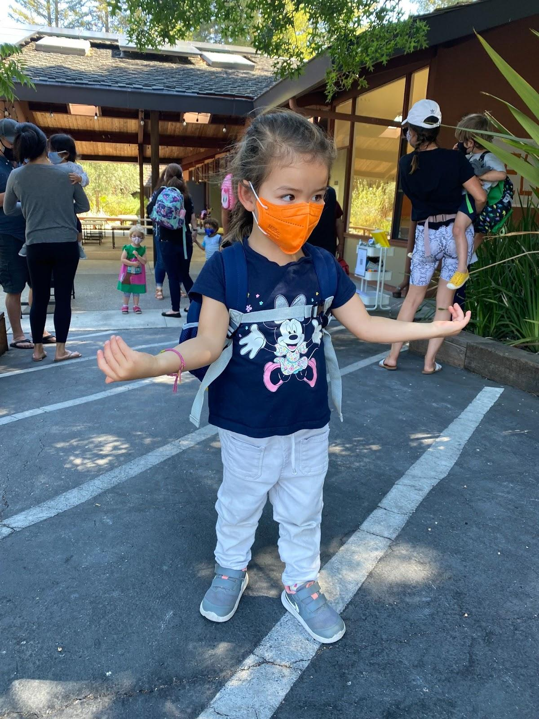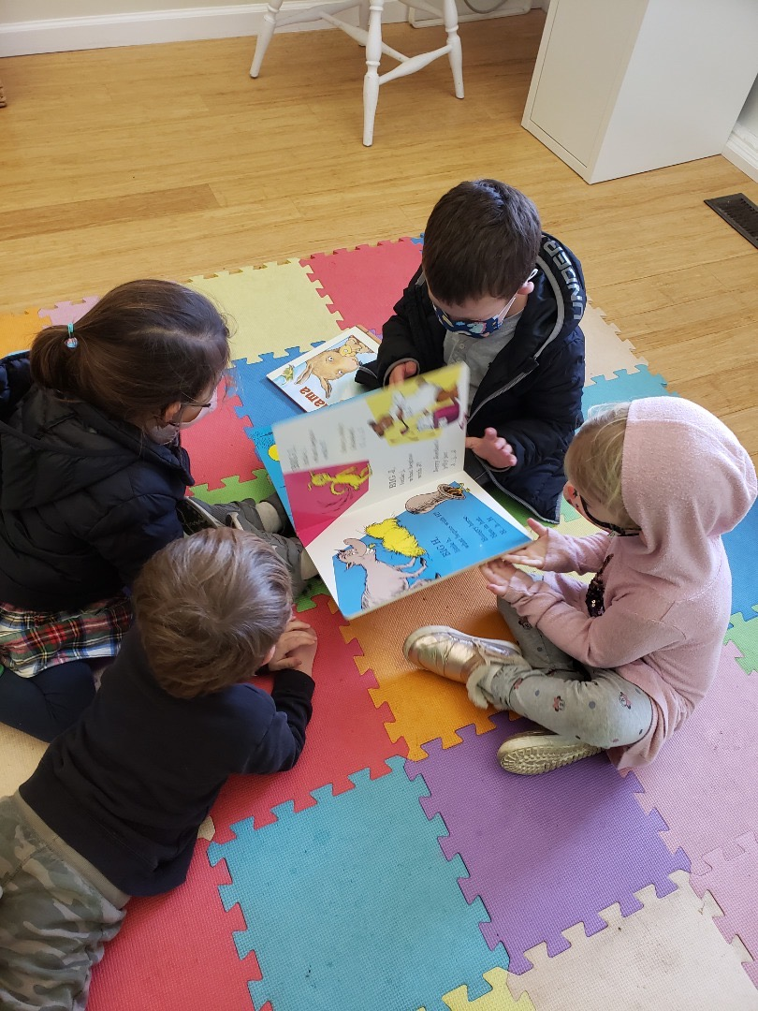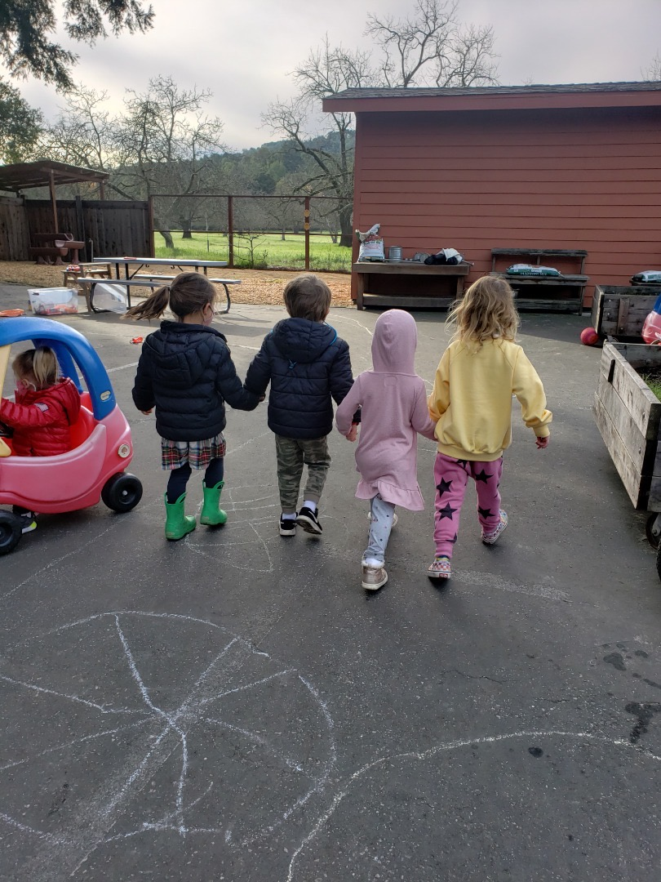

Special thanks to New England Biolabs for support and generous donation of reagents.

Table of Contents
About FloodLAMP 3
Importance of Preschool and Early Childcare Screening 3
Overview of FloodLAMP Surveillance Screening 3
California Preschool Pilot Details 4
Omicron Surge 5
Case Study: FloodLAMP vs BinaXNow Ag 6
Case Study: FloodLAMP vs iHealth Ag 6
Program summary: how it works 7
Program onboarding 7
At-home collection 7
Drop off at school 8
Near-site processing and true turnaround time 8
Program administration 8
Testing schedule 8
Notification and Reporting 8
Admin portal 8
Testing Data 9
Impact and feedback from the community 10

About FloodLAMP
FloodLAMP’s mission is to enable globally scalable mass disease screening, for COVID-19 and beyond. We are a Public Benefit Corporation focused on distributing accurate and affordable molecular testing. We have innovated on multiple fronts to create a best-in-class platform that is unique in the testing space. The test chemistry is an instrument-free, extraction-free rapid molecular LAMP test that is visually read with a simple color change. We are expanding to high priority populations during the pandemic to address the acute unmet need for accessible, effective testing. For more about our programs, plans, mission and how you can get involved, please contact us through the website at floodlamp.bio.

Importance of Preschool and Early Childcare Screening
There are over 23 million children in the US who are under 5 and are only recently eligible for the COVID-19 vaccine. Despite Omicron’s overall reduced severity, the 2021/2022 winter surge resulted in a sharp rise in hospitalizations of young children to record levels. This is concerning and should prompt a committed response to better protect this vulnerable group. Additionally, the stress and practical problems that result from preschool outbreaks have taken a severe toll on families and communities, as described in many articles.

Overview of FloodLAMP Surveillance Screening
“Surveillance” is the technical term for testing that is non-diagnostic and not medical. Surveillance testing or screening looks for infection in a population or community, and has expanded greatly during the COVID-19 Public Health Emergency. The information from surveillance testing can be used for the purpose of stopping the spread of the disease and for managing risk mitigation measures for the group. No exchange of personal health information is required for surveillance. Further, a much greater degree of flexibility in where and how testing is implemented enables programs such as FloodLAMP’s to improve safety and enable groups to interact naturally and confidently.

FloodLAMP has successfully operated 10 surveillance programs in 4 states, screening first responders, entire municipal workforces, preschools, and other organizations. The programs span a wide range of scales and configurations that include both FloodLAMP staff and partner/customer staff doing the administration and running the tests. During the Omicron surge, we supported the rapid ramping up of test volume, especially for our EMS and municipal workers programs, and FloodLAMP became the go-to testing modality over slower, expensive lab PCR and less accurate antigen tests. These programs use the FloodLAMP Mobile App to register who is in the sample pools, which are typically co-workers collecting on-site at their workplaces or families collecting at home. The program is optimized to be run from barebones locations that can be on- or near-site, which significantly shortens sample-to-answer turnaround time.

Recently in our California preschool pilot, we’ve deployed at-home pooled collection by families in what, to our knowledge, is a first of its kind program. Pooled testing has grown during COVID however it consists primarily of pooling random samples at a central lab. Programs utilizing the pooling of student samples from a single classroom, at the levels of 10-20, have been largely ineffective and unpopular due to the delay and disruption from finding out someone in a classroom was positive 1-2 days ago.

FloodLAMP takes a different approach with family/household pooling. This increases the protection of the interacting group, such as a school or workplace, by extending coverage to another population layer, and thus giving advance warning or infection risk for the group member. The advantages of family pooling are especially important during high prevalence, where the standard guidance is that pooling isn’t appropriate or effective. Having a program that continues to perform efficiently and effectively in the face of rising cases is game changing. Inter-household transmission remains the primary vector for community spread. Picking up a positive in the family provides an early warning signal, giving the family the opportunity to use a brief quarantine or test-to-stay to stop spread in the school itself. Our decentralized, local screening model gives the flexibility to quickly deconvolute positive pools on the same day, finding which family members are infected and allowing them to take precautions to protect other family members and their community. In both our FloodLAMP operated programs and those run by our EMS partners, we have used this successfully to stop the pernicious asymptomatic spread within first responders, offices, schools, and even households.

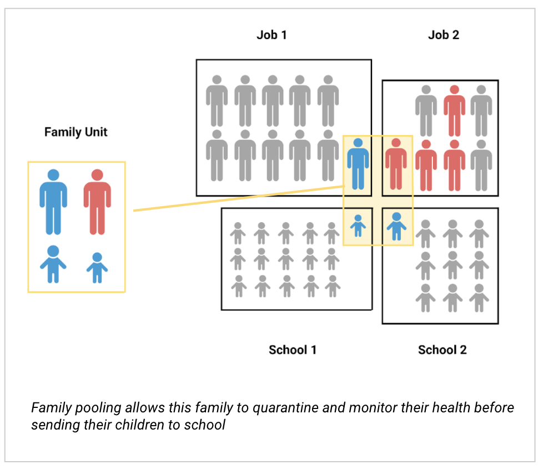

We believe the program described below is among the most effective COVID-19 suppression approaches utilized in schools or any other setting. It rivals and potentially exceeds that of very expensive testing programs used in sports and entertainment. Through working with a number of collaborators and partners, we’ve shown what’s possible when disease screening is reconsidered from the ground up. We are actively working to disseminate our programs nationally and globally as a model of this cornerstone capability of pandemic preparedness and response.

California Preschool Pilot Details
Approximately 40 families attend the California preschool that participated in FloodLAMP’s pilot program. The school has programs serving kids as young as 18 months up to pre-K. Since early 2020, they have taken a proactive approach to safeguarding the school: limiting class pod sizes, purchasing and installing air purifiers, providing ample ventilation, and primarily holding class activities outdoors when the weather permits. FloodLAMP first engaged with the preschool to begin a pooled family testing pilot program after the 2021 November/Thanksgiving break.

The program began with voluntary participation with bi-weekly testing on Mondays and Tuesdays. The voluntary participation rate was around 25% initially, but increased to about 50% by the end of the year. SARS-CoV-2 was not detected in any samples during the November and December 2021 timeframe.

Omicron Surge
As the school went into Winter Recess, the Omicron surge was hitting the US, prompting the school to “strongly encourage” participation in the program. Over the break, several additional families opted into the program. At this point FloodLAMP had not yet picked up any positive results from the school.
This changed after the break. On Sunday January 2nd, FloodLAMP tested 12 family pools. Of these pools, 2 were unknown new positives. The families were referred to follow-up diagnostic testing and the school administrators were immediately notified. The 2 positive families were asymptomatic and unaware that they had contracted COVID-19.
At about 9pm, Carillon administrators made the decision to move to mandatory testing for all returning students. They would not accept antigen test results, requiring molecular testing by either PCR or FloodLAMP. The county-sponsored community PCR testing offered at the local middle school took 4 days to return results from samples taken on Monday, January 3. That same day FloodLAMP returned results in 75 minutes.
FloodLAMP continued 2x/week mandatory testing for Carillon from January to June. The preschool has maintained a 100% participation rate (excluding individuals within their 90 day post-infection “testing holiday”). There was a single exposure warning in May of 2022 (resulting in increased testing), zero closures, or no outbreaks at the school for the entire 2021-2022 school year.
Results from Monday 1/10/22 Results from Thursday 1/13/22
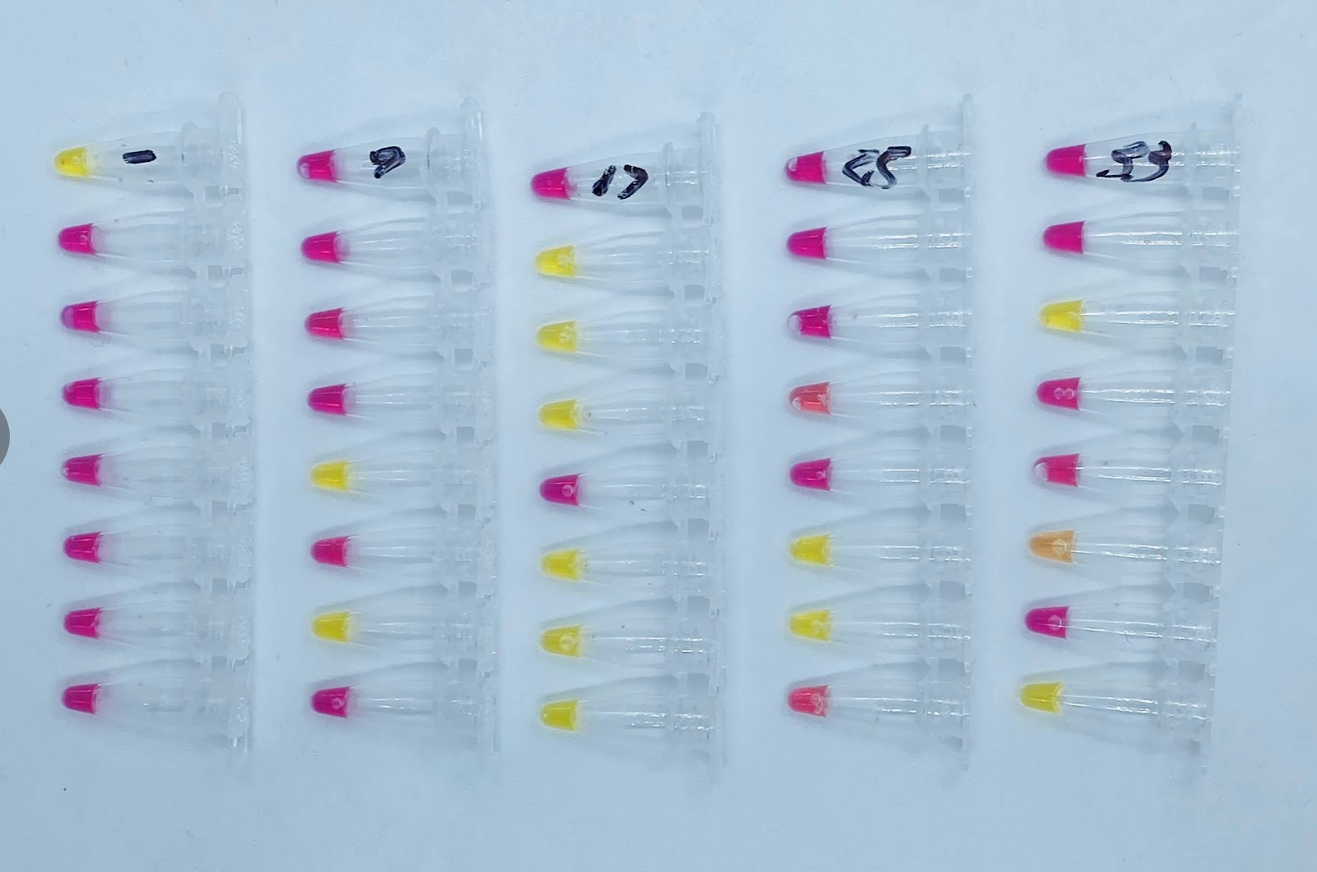 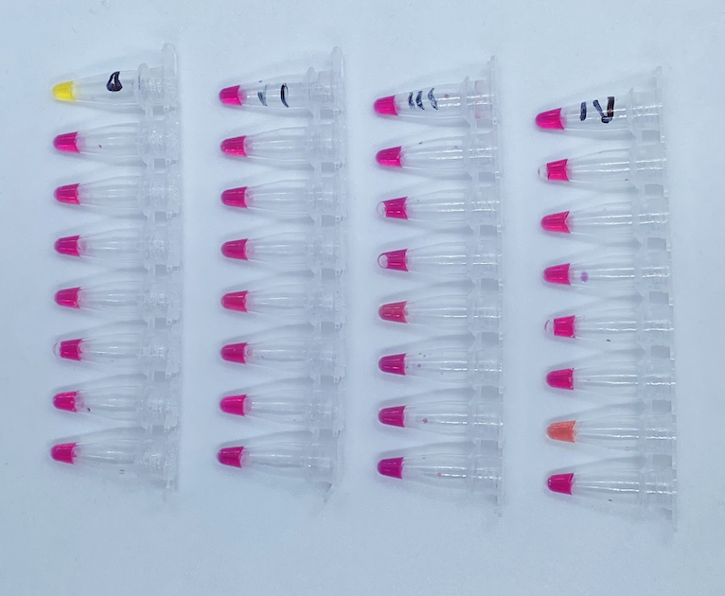
Yellow = positive (each run has 1 positive control; several individual samples included for confirmation 1/10/22)
Pink = negative

Case Study: FloodLAMP vs BinaXNow Ag
One of the families referred to follow-up diagnostic testing on 1/2/22 had no symptoms and no known exposure. Following FloodLAMP’s referral:
- The parents tested with Abbott BinaXNow antigen tests that evening – both returned negative results.
- On 1/3/22, FloodLAMP re-tested all 4 family members individually. Both parents’ samples were positive and the 2 children negative. The parents were once again referred to follow-up diagnostic testing and the family isolated.
- On 1/9/22, both children subsequently tested positive by FloodLAMP. The chart below details the case progression and testing history for each family member:

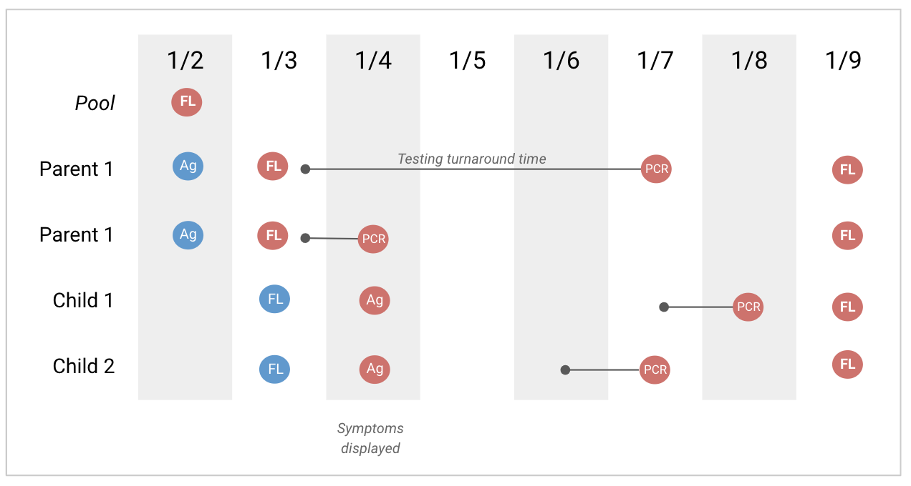
Blue = negative; Red = positive

This example illustrates the improved performance of the FloodLAMP test over antigen test strips in finding new infections early and thus stopping spread. Our other deployments have also seen many instances of the FloodLAMP test picking up new cases 1-2 days before antigen tests. This case study also highlights the power of family pooling. Testing students once a week by even 24 hour turnaround PCR leaves significant opportunity for outbreaks and all the negative downstream consequences.

Case Study: FloodLAMP vs iHealth Ag
On Monday 5/2/2022, FloodLAMP tested 24 families and found 1 positive pool. Families had previously been screened Thursday 4/28. All 4 family members (who were asymptomatic) were referred to follow-up diagnostic testing and school administrators were immediately notified. Following the referral:
- The student was picked up before noon, while school was still in session.
- All 4 family members retested with iHealth antigen tests within an hour of the referral from their positive surveillance test. All antigen test results were negative.
- All 4 family members submitted samples for lab based PCR testing early in the afternoon, being told results would take at least 24 hours.
- FloodLAMP deconvoluted the pool with individual testing of 3 of the family members early in the afternoon and the 4th in the evening. Running the 3 samples took less than 10 minutes of hands-on time and costs less than $10.
- Only one family member (the elementary school age sibling of the preschool student) was found to be positive by the deconvolution FloodLAMP testing and referred again to follow up diagnostic testing.
- The sibling was isolated at home on Monday afternoon awaiting the PCR results and further antigen testing.
- On Wed morning, the sibling tested positive by antigen test. The PCR results were received that morning as well, confirming FloodLAMP’s results of the single positive within family.
- The positive sibling remained asymptomatic throughout.
- No other family members tested positive in further testing over the next week, by both antigen and FloodLAMP surveillance testing. They were able to effectively quarantine and mask, preventing inter-household transmission due to the early detection.

This case again illustrates the benefit of accurate, frequent and flexible surveillance screening in both preventing outbreaks in the school setting and disruption from potential exposure. Additionally, through family pooling and the early identification of an asymptomatic case, even intra-household transmission was prevented.

Program summary: how it works

Program onboarding
There are 2 parts to the program onboarding:
- Consent – All participants submitting samples must sign a consent form. In this pilot, this has been done by individual parents/caregivers who also consent on their minors’ behalf. This may also be administered by the school for efficiency.
- App account set up – All program participants are required to create FloodLAMP accounts, but only 1 adult per household is required to actively use the FloodLAMP Mobile App to record and submit samples. Program administrators create and manage the accounts. Alternatively, families may sign up through a web form.

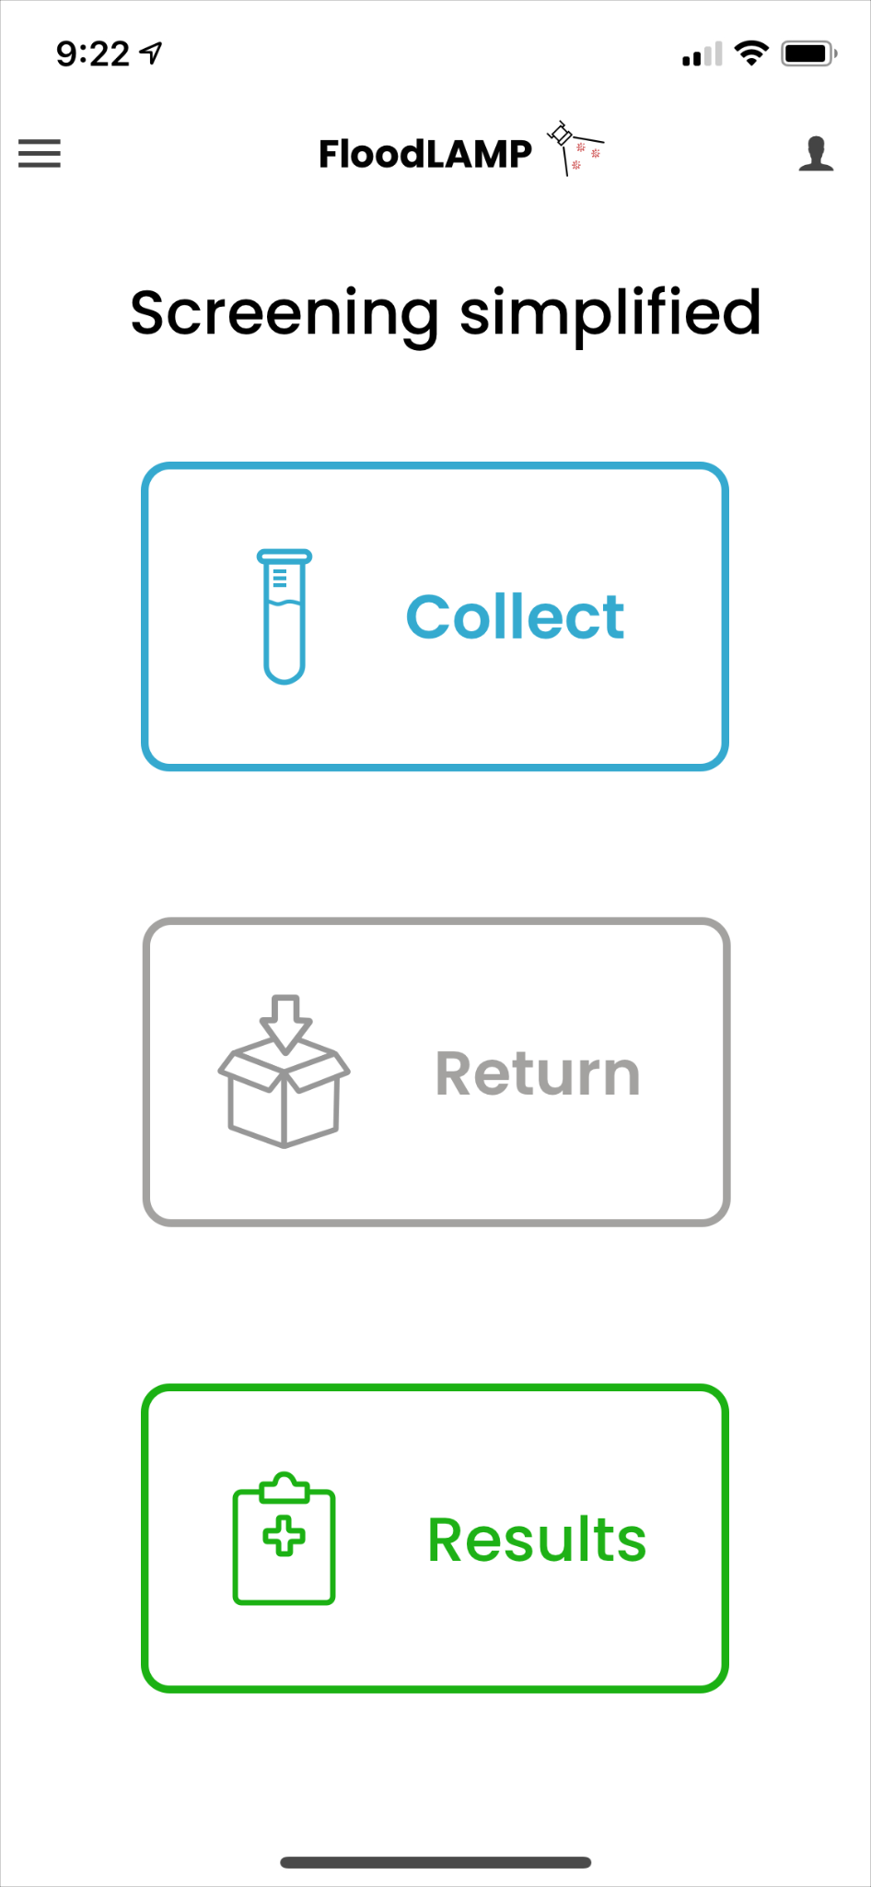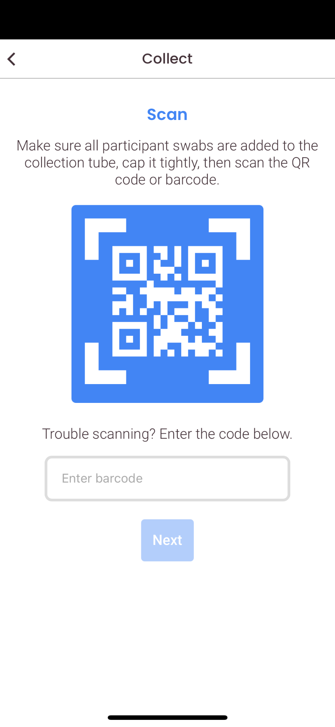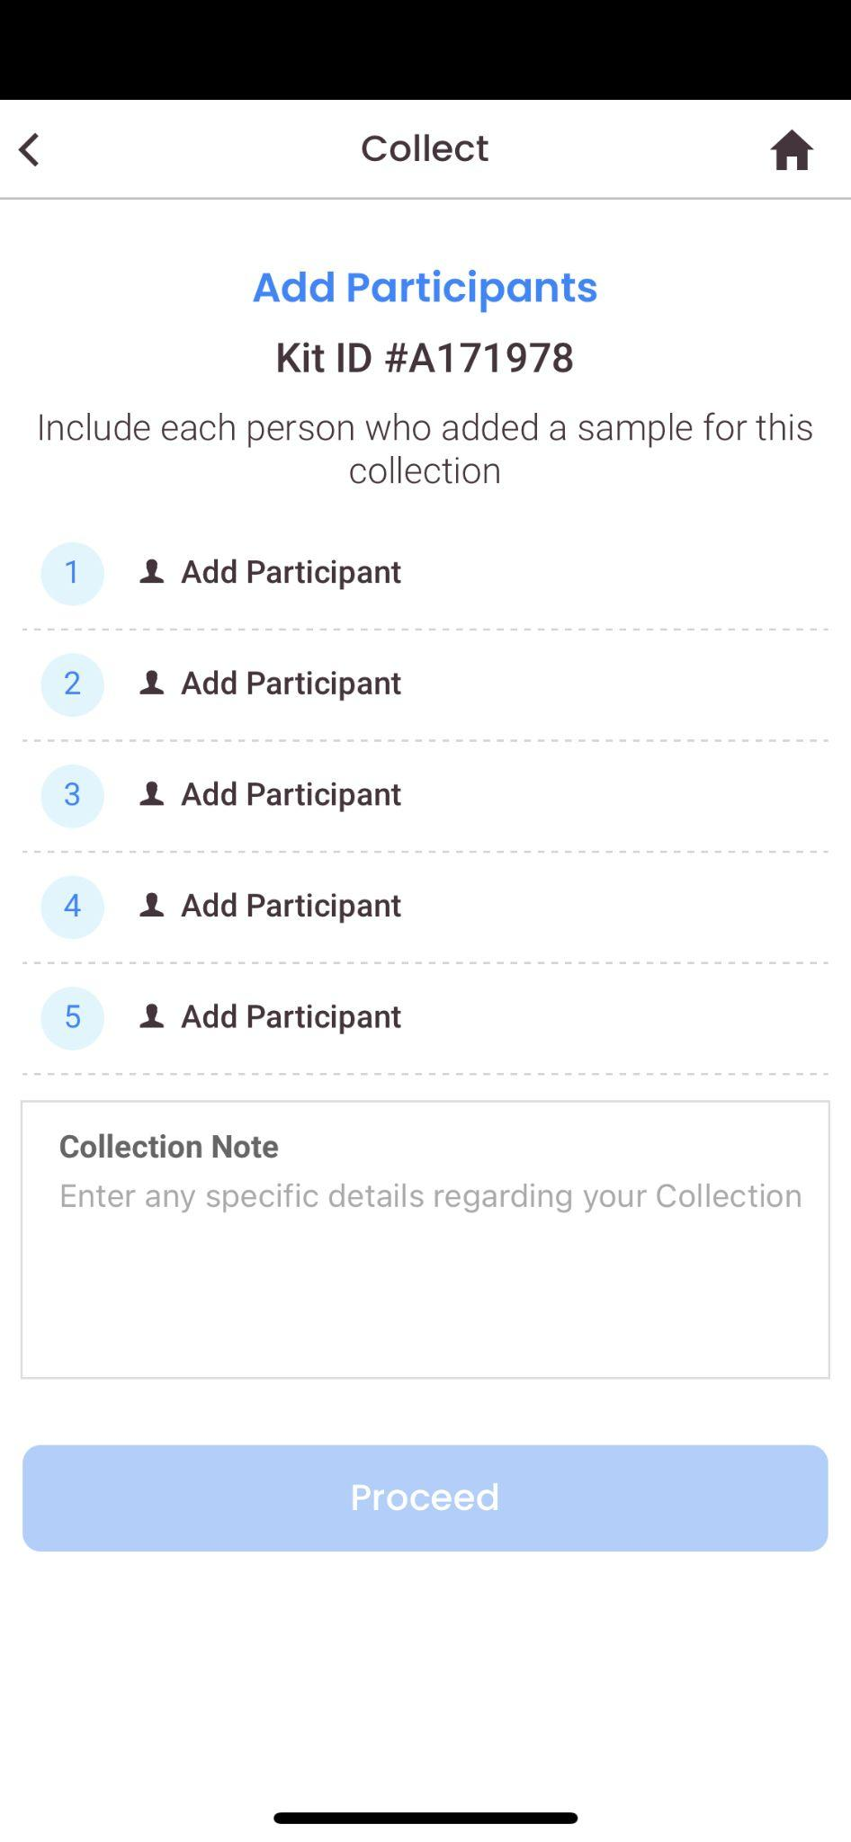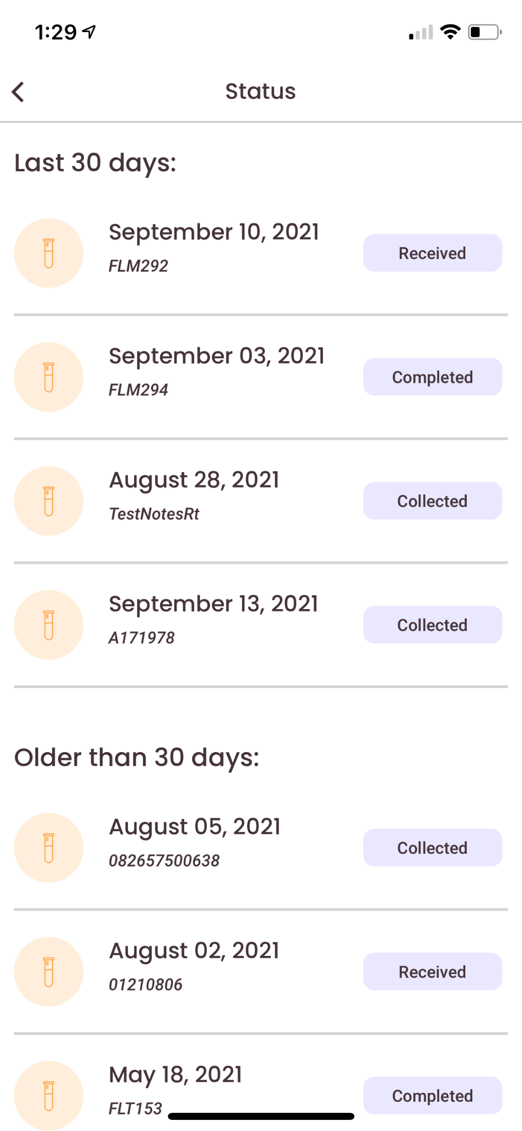

At-home collection
Families pick up collection kits on campus. Each kit includes instructions and all the tubes and swabs needed for sample pools of 4. Families collect at home using the app. They must collect within 24 hours of the drop off time.

Drop off at school
There is an on-site drop box for returning samples. The return schedule generally coincides with the regular school drop off time for convenience. The teachers help to check that students entering the classroom have submitted samples on testing days.

Near-site processing and true turnaround time
Samples are picked up and run for processing near-site (5 minutes away). This near-site model ensures the fast turnaround time, which is essential to managing and preventing outbreaks. Turnaround time for samples has usually come in under 2 hours, with results available well before school is out.

Program administration

Testing schedule
Testing for the majority of the school year was twice per week, on Monday and Thursday mornings. We determined that 2X/week was an optimal balance of very high protection without being too onerous. This extra protection is due to a combination of factors in our program: 1) mandatory participation, 2) family pooling, 3) the accuracy of our molecular test in picking up early infections (in contrast to antigen test strips), and 4) the rapid 2 hour or less turnaround time (in contrast to central lab PCR).
Samples were dropped off by 9am when classes start. After holidays (Thanksgiving, Christmas/New Years, and MLK), testing was performed the evening before school resumed. This holiday protocol helps a great deal because students attending class that first day back have had their entire families test negative by a high accuracy molecular test within the last 24 hours. It does however have the tradeoff of needing families to make an extra trip to drop off samples on a Sunday. Convenience for families is a major part of our approach to program design. We strive to make all aspects of FloodLAMP testing as easy as possible, so people continue to participate and have a satisfying experience. However, there are tradeoffs such as Sunday evening testing, which can be decided along with other mitigation protocols, such as masking Monday mornings.

Notification and Reporting
We operate under the CMS regulatory framework of Surveillance Screening. As such, FloodLAMP does not provide results to program participants. Instead, positives are referred to follow-up diagnostic testing and negatives are not notified. The FloodLAMP app has a status list that will indicate to program participants when the surveillance screening is complete. Following each screening, the FloodLAMP program administrator sends a complete report of participation and results to the school administration. It is up to the school to enforce their COVID-19 policies based on the reports.

Admin portal
The app platform portal enables program administrators to manage users, check kit statuses, look up tubes by ID or name, and edit information pages in the app.
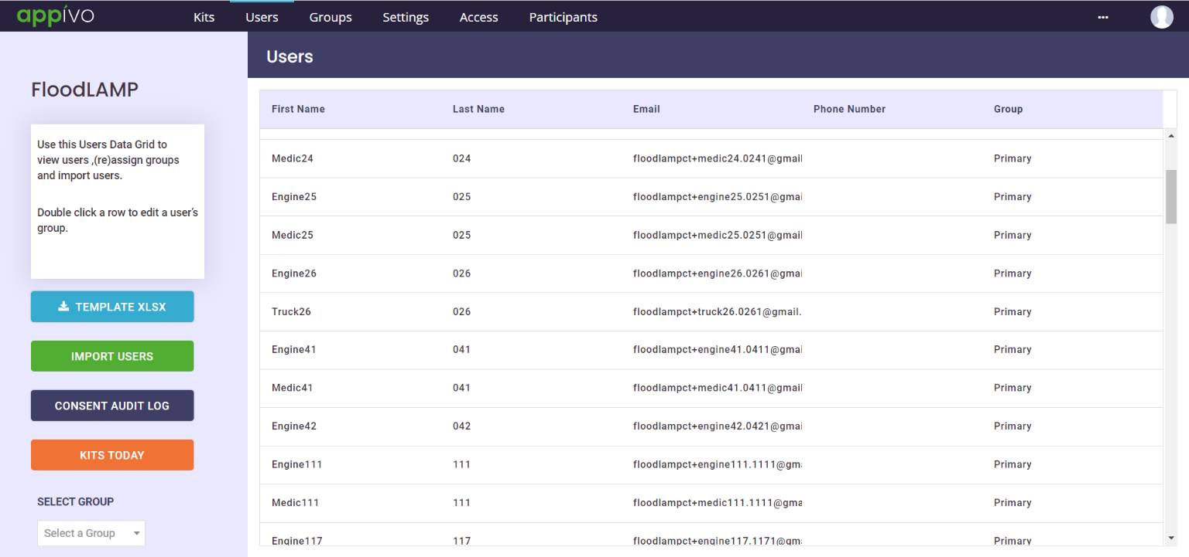

Testing Data
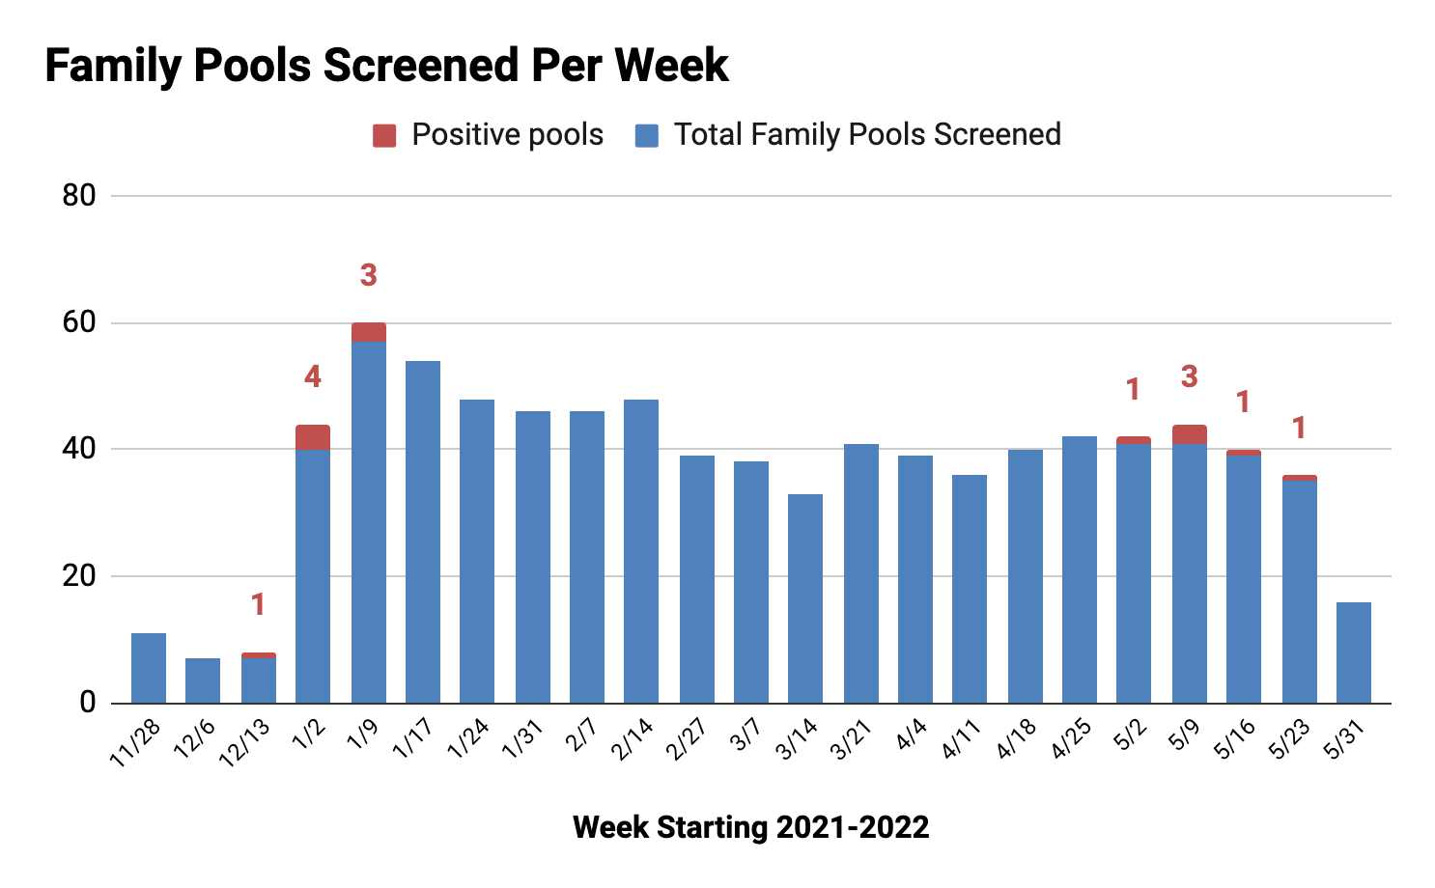
Positives clustered during Jan and May surges.

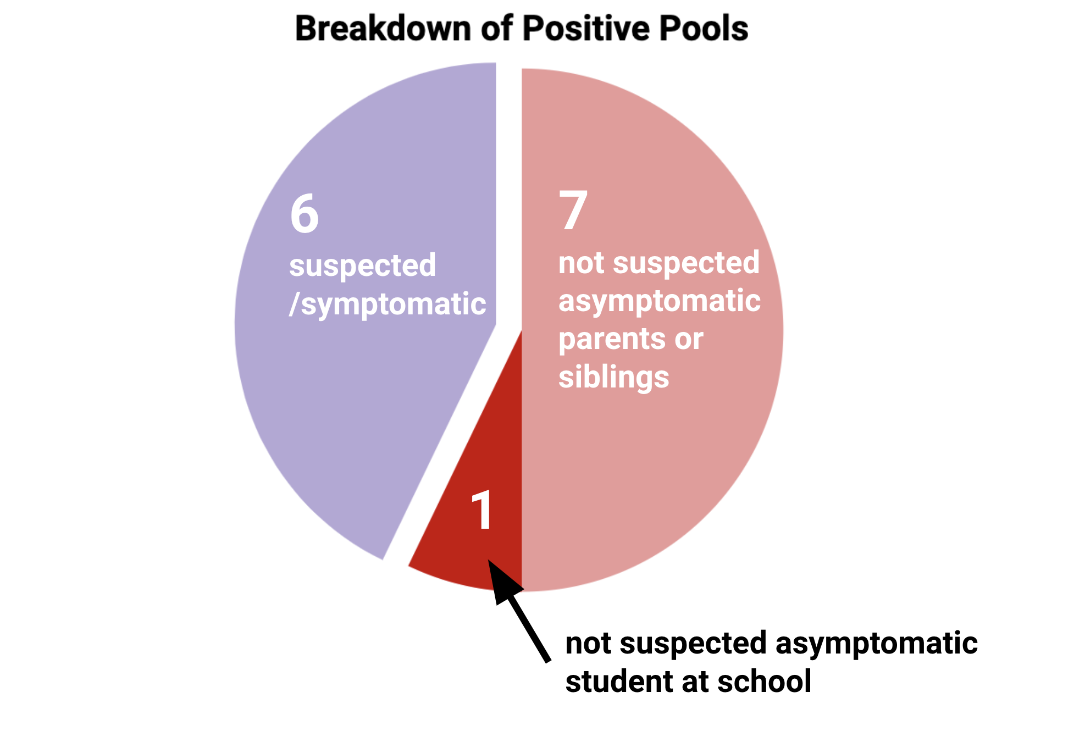
Only 1 positive pool included a student that was on campus. For the truly unknown asymptomatic cases, all but this one were parents or siblings of the preschool student, providing the critical advance warning and extra protection of family pooling.

Impact and feedback from the community
Unlike most nearby preschools and childcare centers, the piloting school has not had any COVID-19-related closures since FloodLAMP began its surveillance screening program. Positivity rates dramatically climbed in January 2022 and again in early May, however, the program has effectively suppressed potential outbreaks.

No school-based transmission has been reported and families have been able to test-to-return and test-to-stay, allowing for the highest possible in-person attendance. FloodLAMP and the school are now close partners, and they have come to rely on FloodLAMP for guidance around protocols and safety.

Importantly, the program has helped to quell some of the pandemic-driven anxiety in the community (which is especially acute for families with children under 5), and the feedback has been overwhelmingly positive:

“I really appreciate this process. [Name] tested positive on an antigen test at home today and is now showing symptoms, so I truly appreciate the surveillance program picking this up! Thank you again!!!”
- Parent of a student who was referred to follow-up testing while negative on antigen and pre-symptomatic

“Thank you so much for helping to get our kids tested and doing what you can to keep them safely in school! We are all so lucky to have you as part of our community!”
- Parent of a student and MD, wrote to school administrators to move to mandatory testing with FloodLAMP

“I thought [FloodLAMP] was perfect. Easy and convenient.”
- Parent of a student and restaurant owner who later wanted to extend FloodLAMP testing to her restaurant employees

“You are a godsend to our community. I cannot begin to thank you for all of your support and love in keeping our community safe in this difficult time.”
- Preschool teacher and administrator

The omicron surge is causing chaos and anguish for parents of kids under 5, Rachel Swan, SF Chronicle, Jan. 20, 2022
The Agony of Parents With Kids Under 5, Jaime Green, Slate, Jan 11, 2022

